**Graded lab 02 DSA:**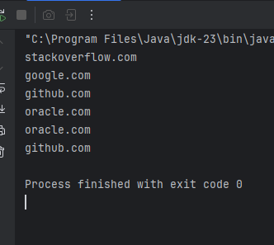

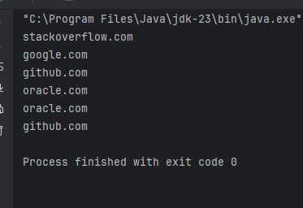

import java.util.Stack;  
  
public class browser{  
 Stack<String> Back;  
 Stack<String> forward;  
 String currentPage;  
  
 public browser() {  
 Back = new Stack<>();  
 forward= new Stack<>();  
 }  
 public void visit(String url) {  
 if (currentPage != null) {  
 Back.push(currentPage);  
 }  
 forward.clear();  
 currentPage = url;  
 }  
 public void goBack() {  
 if (!Back.isEmpty()) {  
 forward.push(currentPage);  
 currentPage = Back.pop();  
 }  
 else {  
 System.*out*.println("back stack is empty:");  
 }  
 }  
 public void goForward() {  
 if (!forward.isEmpty()) {  
 Back.push(currentPage);  
 currentPage = forward.pop();  
 }  
 }  
 public String showCurrentPage() {  
 return currentPage;  
 }  
 public static void main(String[] args) {  
 browser b = new browser();  
 b.visit("google.com");  
 b.visit("github.com");  
 b.visit("stackoverflow.com");  
  
 System.*out*.println(b.showCurrentPage());  
 b.goBack();  
 b.goBack();  
  
 System.*out*.println(b.showCurrentPage());  
  
 b.goForward();  
 System.*out*.println(b.showCurrentPage());  
  
 b.visit("oracle.com");  
 System.*out*.println(b.showCurrentPage());  
  
 b.goForward();  
 System.*out*.println(b.showCurrentPage());  
 b.goBack();  
 System.*out*.println(b.showCurrentPage());  
 }  
}

class browser {  
 Node back;  
 Node forward;  
 String currentPage;  
  
 private class Node {  
 String url;  
 Node next;  
  
 Node(String url) {  
 this.url = url;  
 this.next = null;  
 }  
 }  
 public browser() {  
 back = null;  
 forward = null;  
 }  
 public void visit(String url) {  
 if (currentPage != null) {  
 Node newNode = new Node(currentPage);  
 newNode.next = back;  
 back=newNode;  
 }  
 forward = null;  
 currentPage = url;  
 }  
  
 public void goBack() {  
 if (back != null) {  
// Node newNode = new Node(current);  
 Node newNode = new Node(currentPage);  
 newNode.next = forward;  
 forward = newNode;  
 currentPage = back.url;  
 back = back.next;  
 }  
 }  
  
 public void goForward() {  
 if (forward != null) {  
 Node newNode = new Node(currentPage);  
 newNode.next = back;  
 back=newNode;  
// currentPage = forward.url;  
// forward = forward.next;  
 currentPage = forward.url;  
 forward = forward.next;  
 }  
 }  
  
 public String showCurrentPage() {  
 return currentPage;  
 }  
 public static void main(String[] args) {  
 browser b = new browser();  
 b.visit("google.com");  
 b.visit("github.com");  
 b.visit("stackoverflow.com");  
  
 System.*out*.println(b.showCurrentPage());  
  
 b.goBack();  
 b.goBack();  
 System.*out*.println(b.showCurrentPage());  
  
 b.goForward();  
 System.*out*.println(b.showCurrentPage());  
  
 b.visit("oracle.com");  
 System.*out*.println(b.showCurrentPage());  
  
 b.goForward();  
 System.*out*.println(b.showCurrentPage());  
  
 b.goBack();  
 System.*out*.println(b.showCurrentPage());  
 }  
}